NAME- Himangi Bhatt

UID-23BCC70020

SUB-ADBMS

EXPERIMENT-02

* AIM:- Part A

Title: Create Department and Course Tables with Normalization (up to 3NF)

* **CODE:-**

-- Drop if exists for clean re-execution

DROP TABLE IF EXISTS Courses;

DROP TABLE IF EXISTS Departments;

-- Create Departments table

CREATE TABLE Departments ( dept_id INT PRIMARY KEY,

dept_name VARCHAR(50) UNIQUE NOT NULL

);

-- Create Courses table

CREATE TABLE Courses ( course_id INT PRIMARY KEY, course_name VARCHAR(100) NOT NULL, dept_id INT NOT NULL,

FOREIGN KEY (dept_id) REFERENCES Departments(dept_id) ON DELETE

CASCADE

);

• AIM :- **Part B :-**

**Title**: Insert Sample Data into Department and Course Tables

➢ **INSERTION OF DATA:**

**-- Insert Departments**

INSERT INTO Departments (dept_id, dept_name) VALUES

(1, 'Computer Science'),

(2, 'Electrical'),

(3, 'Mechanical'),

(4, 'Civil'),

(5, 'Electronics');

**-- Insert Courses**

INSERT INTO Courses (course_id, course_name, dept_id) VALUES

(101, 'DBMS', 1),

(102, 'Operating Systems', 1),

(103, 'Power Systems', 2),

(104, 'Digital Circuits', 2),

(105, 'Thermodynamics', 3),

(106, 'Fluid Mechanics', 3),

(107, 'Structural Engineering', 4),

(108, 'Surveying', 4),

(109, 'Embedded Systems', 5),

(110, 'VLSI Design', 5);

**-- Insert Courses if more than 2 courses**

SELECT dept_name

FROM Departments

WHERE dept_id IN (

SELECT dept_id

FROM Courses

GROUP BY dept_id

HAVING COUNT(*) > 2

);

**-- Grant Access to the user**

GRANT SELECT ON TABLE Courses TO viewer_user;

* **OUTPUTS:-**

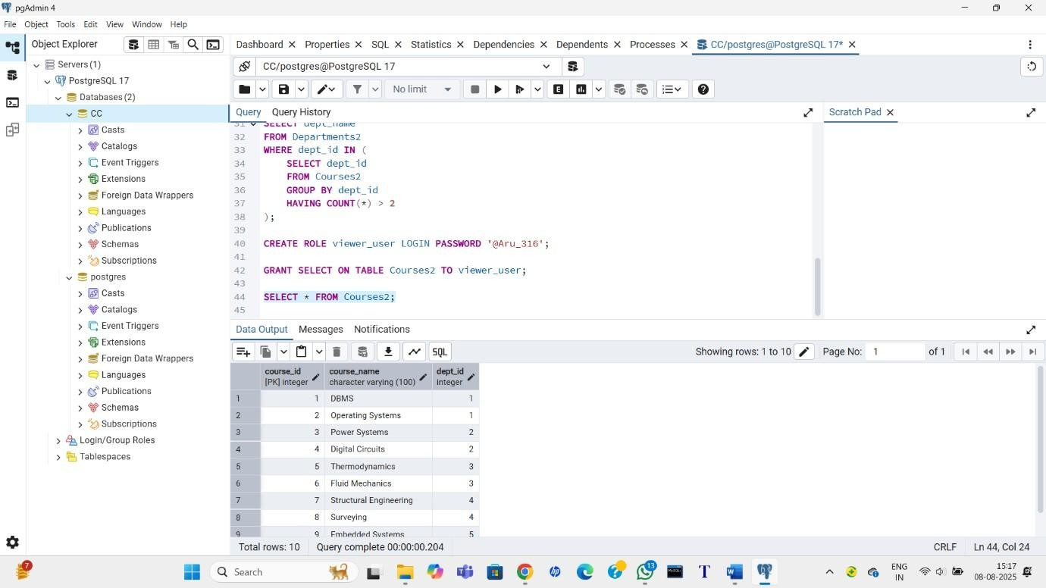

* **LEARNING OUTCOMES:-**
* Understand and apply **3NF normalization** in database design. ➢ Use **foreign key constraints** to maintain referential integrity.
* Write **subqueries** using GROUP BY and HAVING to analyze relationships.
* Implement **access control** using GRANT statements in PostgreSQL.
* Handle **real-world schema modeling** and data organization tasks efficiently.